**SYSTEM’S INSTALLATION MANUAL**

The web application, Student Work Management Information System will keep track and record the different project works of the students from the Department of Computer and Information Sciences. It can also easily monitor the number of thesis submitted every semester and the number of advisee that an adviser handled with the use of the functionality of the system that generates reports automatically. Student researchers can easily find any thesis related to their study.

* 1. **System Requirements**

|  |  |
| --- | --- |
| **Hardware Requirements** | |
| **Device** | **Requirement** |
| Laptop/ Desktop | Intel Core i3 or equivalent |
| **Network** | **Requirement** |
| Internet | 5 MBPS |
| **Software Requirements** | |
| **Operating System** | **Requirement** |
| Windows | Windows 8 or higher |
| **Web Browser** | **Requirement** |
| Google Chrome | 69.0.3497.100 (version) |
| **Web Servers** | **Requirement** |
| XAMPP | 3.2.2 (version) |
| PhpMyAdmin | 4.8.1 (version) |
| Sublime Text | 2.0.2 (version) |
| MySQL | 5.0.27 (version) |
| Composer | 1.8.4 (version) |
| Git Bash | 2.21.0 (version) |
| **PHP Extension** | **Requirement** |
| Imagick | 7.0.8-34 (version) |

* 1. **Installation**

1. Install XAMPP. Open the Xampp website by visiting <https://www.apachefriends.org/index.html>

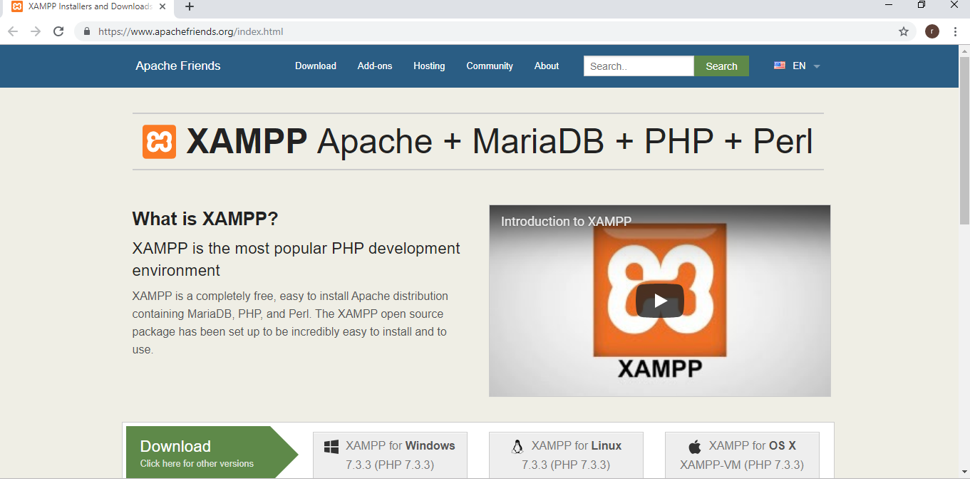

1. Choose Xampp for Windows.

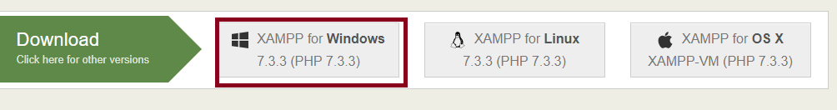

1. Go to downloads folder and double-click the downloaded file. File name should be **xampp-win 32-7.3.1-0-VC15-installer**.

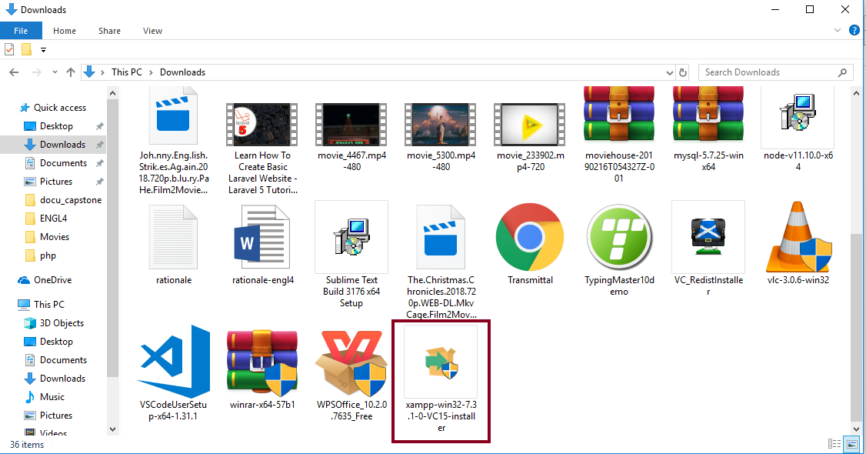

1. When prompted, click YES.

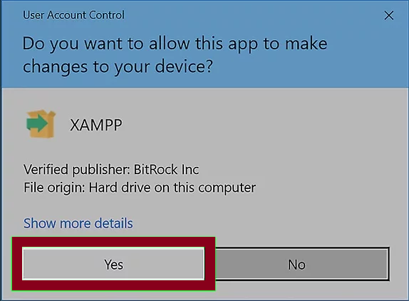

1. Click next at the bottom of set up window.

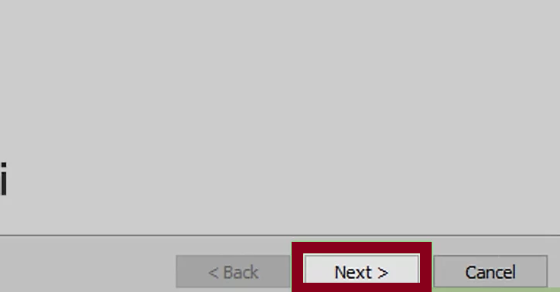

1. Select necessary aspects of XAMPP to install.

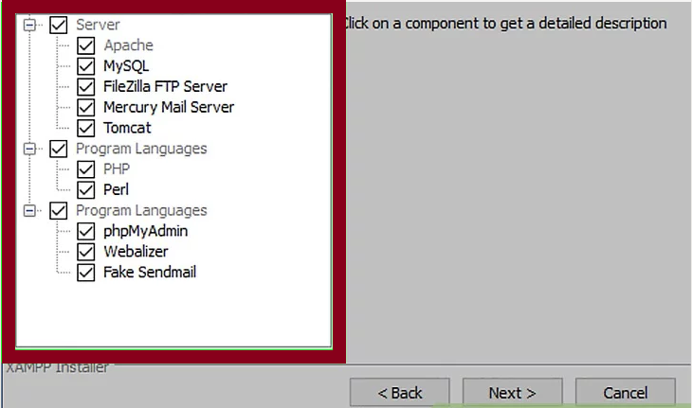

1. Click next at the bottom of the window.
2. When the installation is complete, click on finish and you can now close the window.

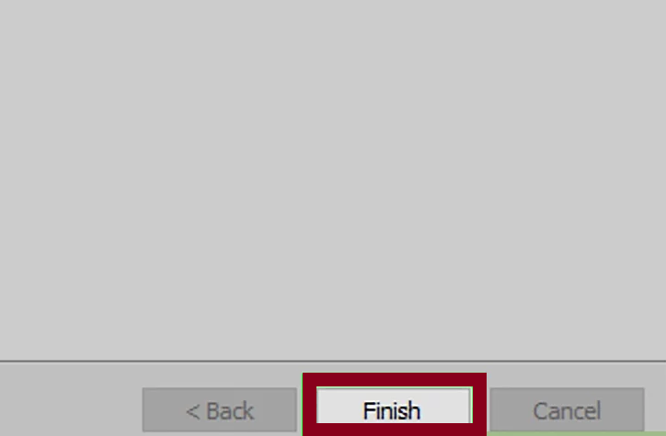

1. 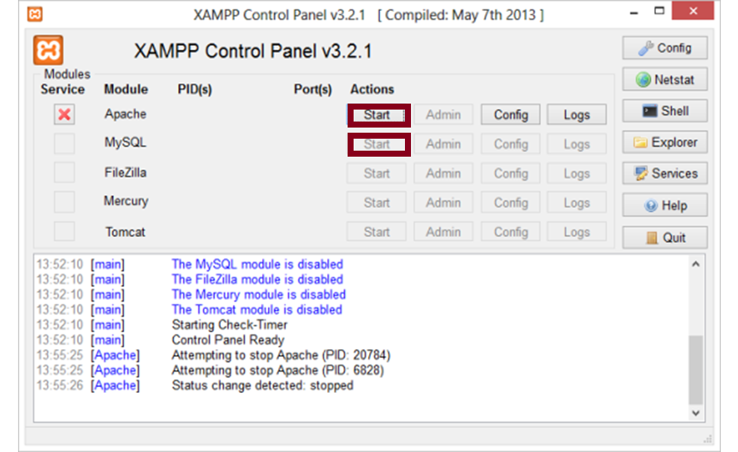Open the Xampp Control Panel and start the Apache and MySQL components.
2. 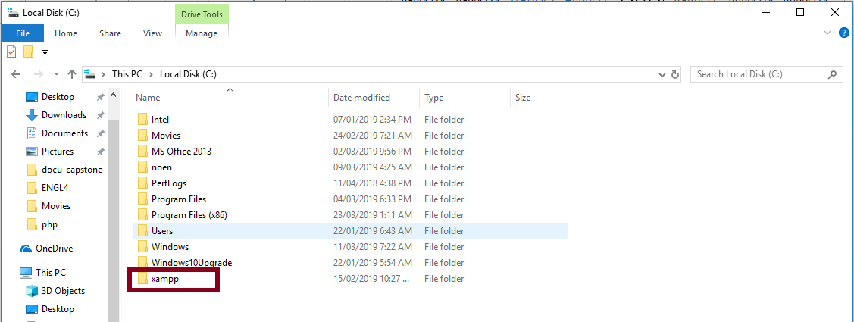Go to Local Disk (C:) and open xampp folder then click htdocs. All applications must be placed in htdocs folder.

**INSTALLING COMPOSER**

1. Open the Composer website by going to this link <https://getcomposer.org/>
2. Click the Download button

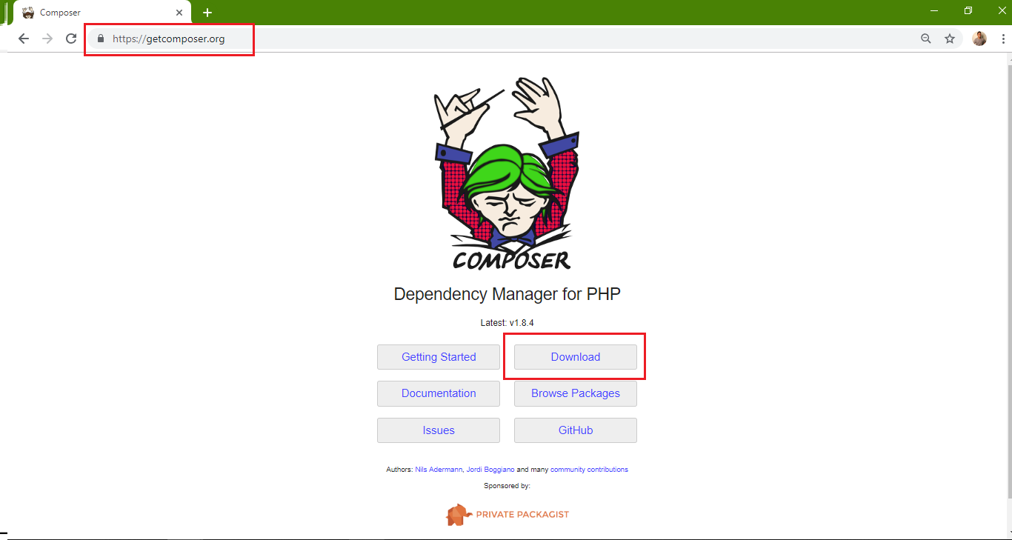

1. Select and download the Composer-Setup.exe link

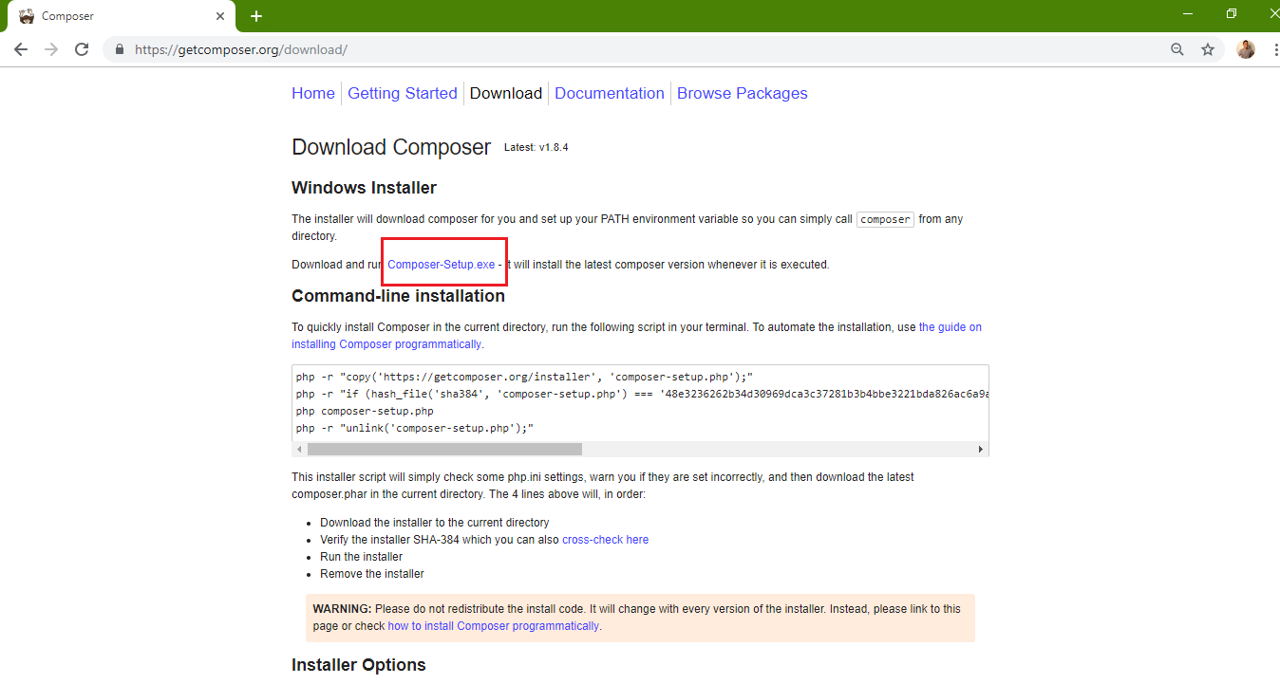

1. Open the downloaded Composer-Setup.exe file and run as administrator on your folder
2. Click the next button

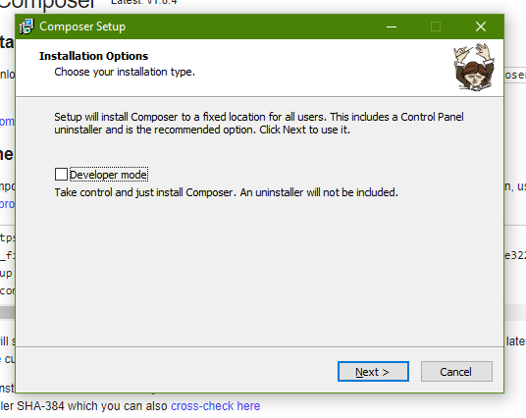

1. Choose the command-line PHP in C:\xampp\php\php.exe then click next.

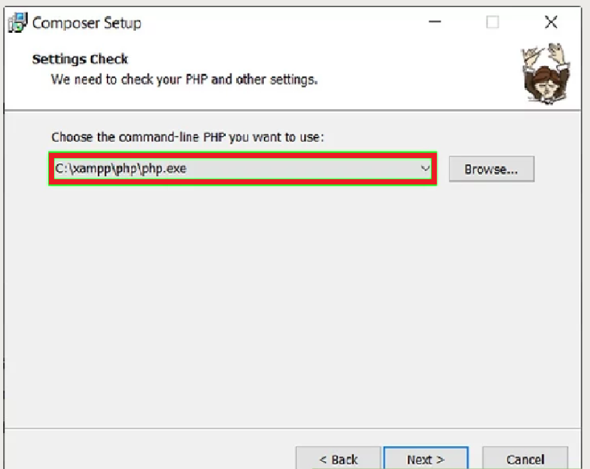

1. Click next

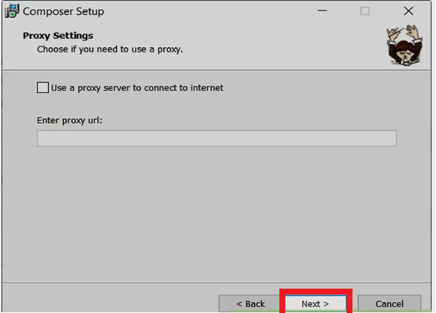

1. Click Install

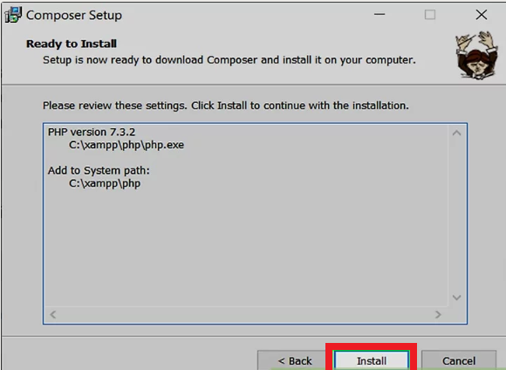

1. Click Finish

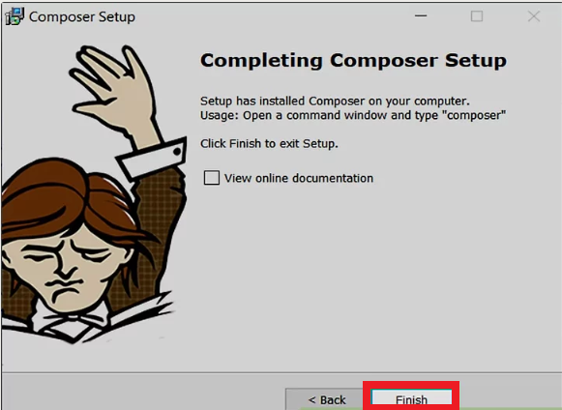

**ACTIVATING COMPOSER**

1. Open Command Prompt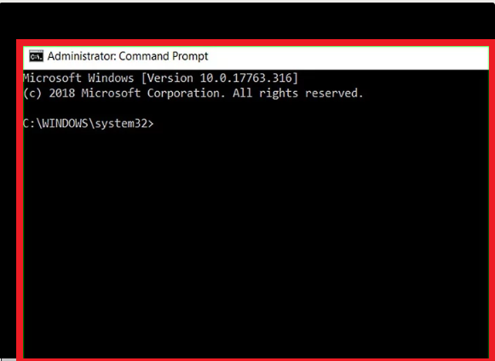
2. Enter the composer validation command.

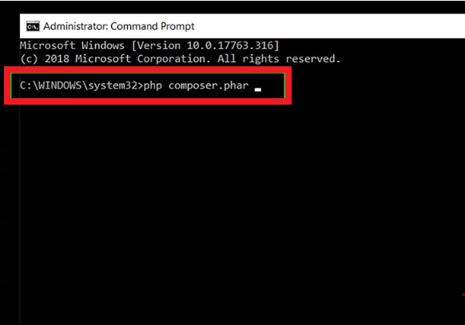

**Installing Git Bash**

1. Search git bash download on your browser or type this link

<https://git-scm.com/downloads>

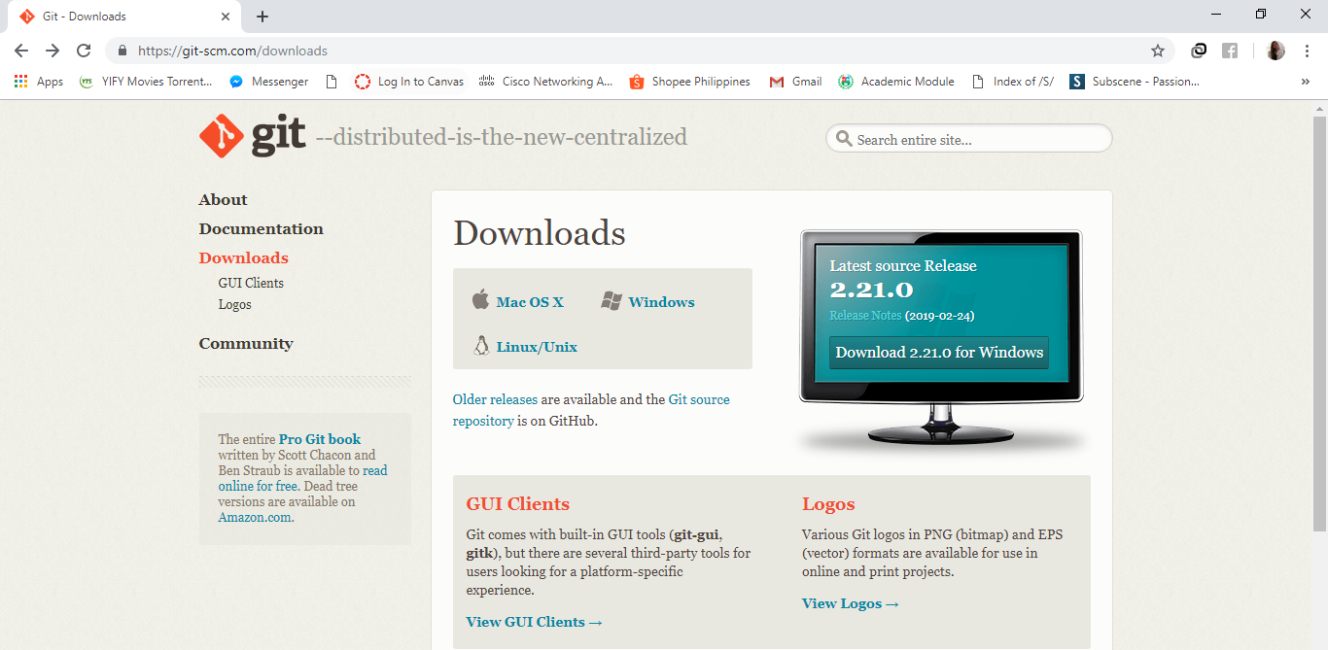

1. Click what Operating System that is compatible for your device.

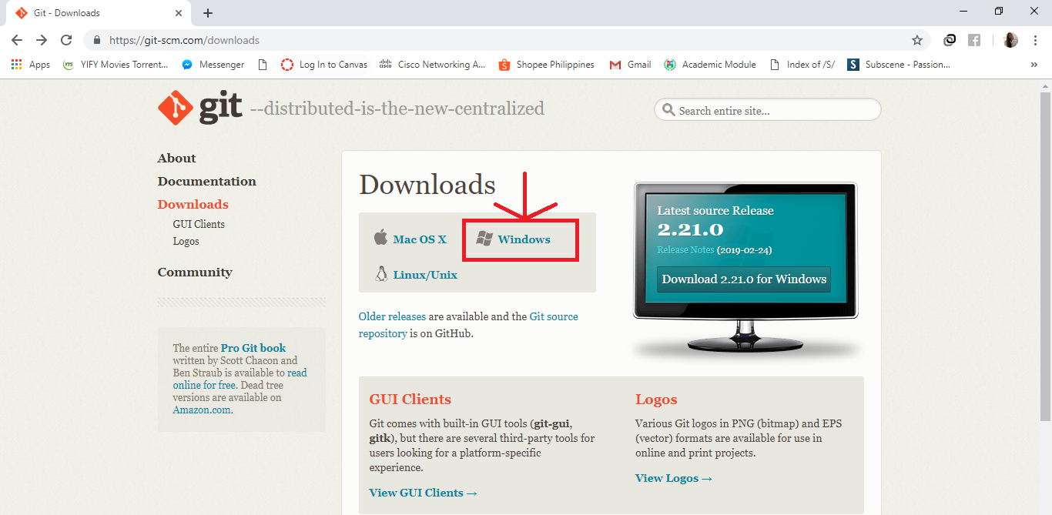

1. Click what is compatible base on your computer’s system type.

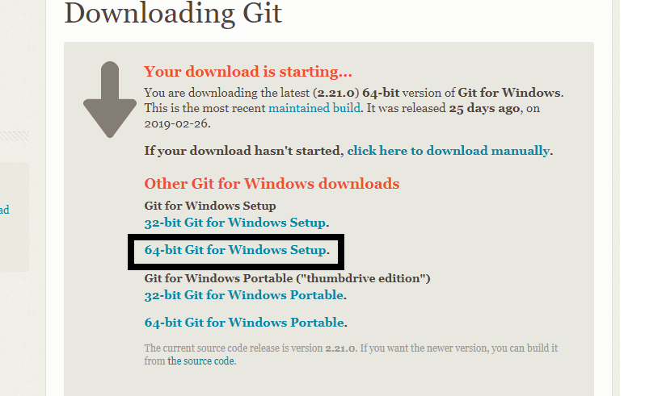

1. Click next button.

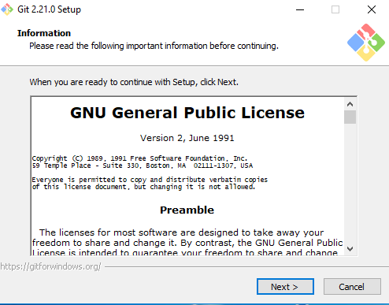

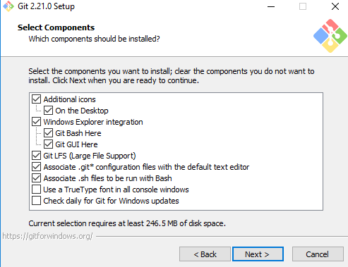

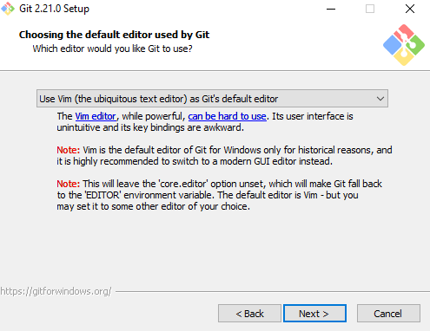

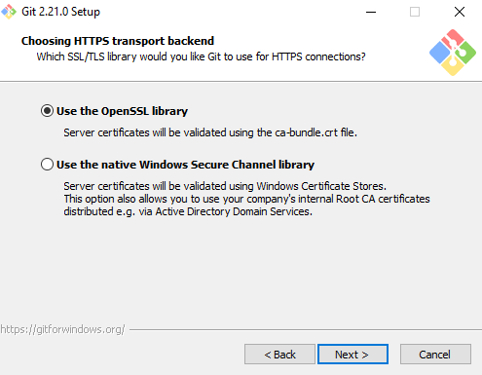

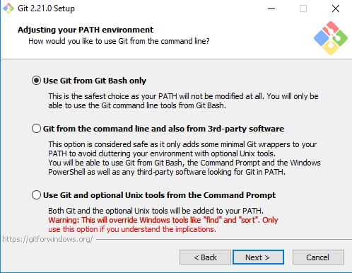

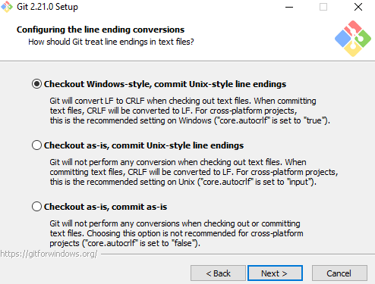

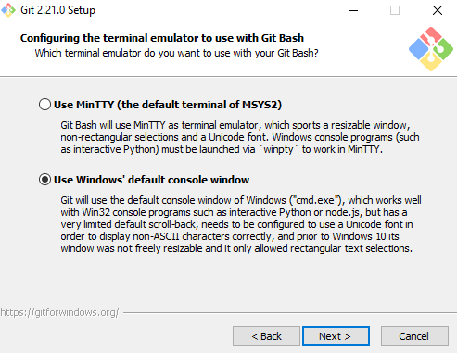

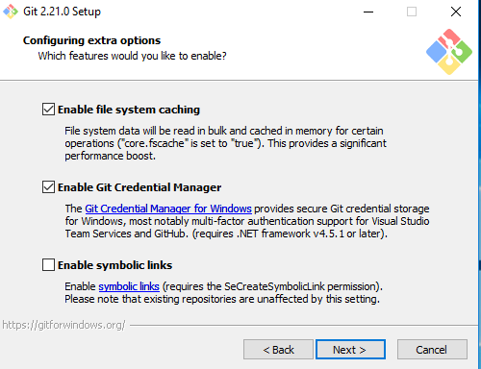

1. Click install button.

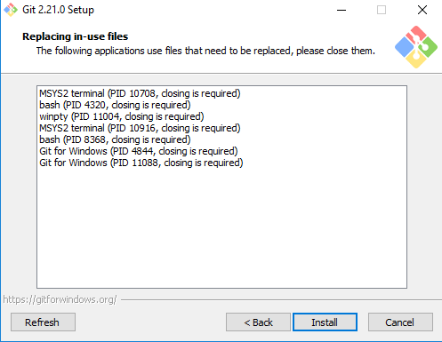

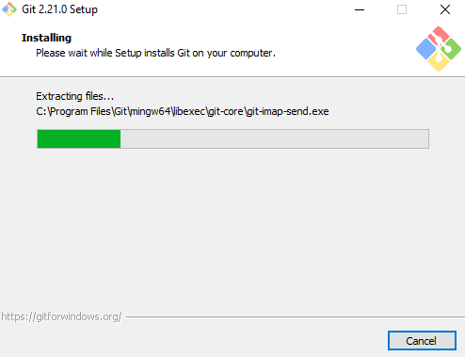

1. When done installing click finish button then close the window.

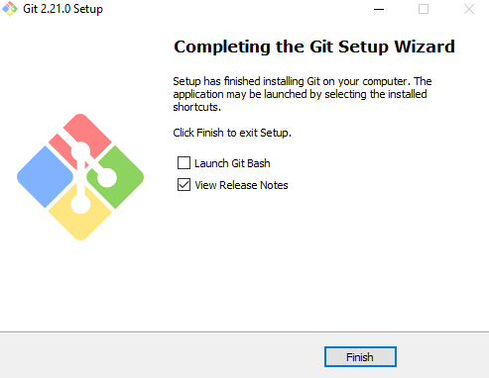

**Installing GhostScript**

1. Download GhostScript installer

2.Click next

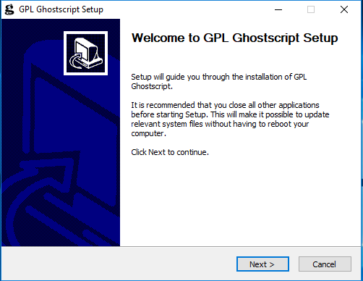

3.Click “I agree”

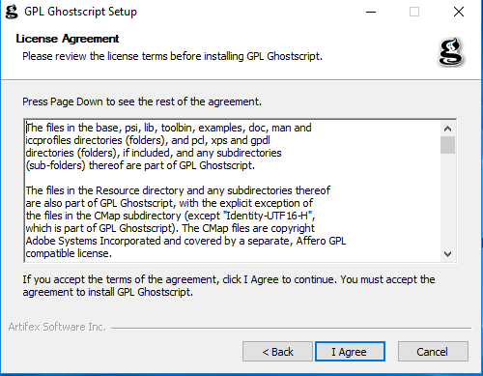

4.Click Install

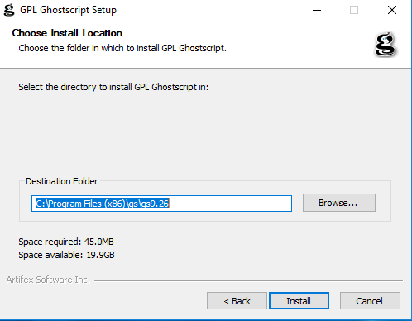

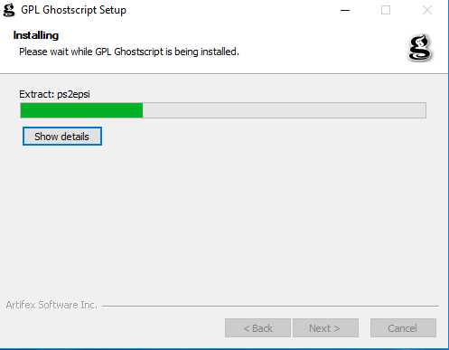

6.Click Finish

